Bank Management System

Submitted in partial fulfillment of the requirements

of the degree of

Bachelor of Engineering

by

Student Name Ayush Yelne Roll No.63

Student Name Pranav Satam Roll No.38

Student Name Manav Modi Roll No.08

Student Name Vikas Yadav Roll No.62

Supervisor:

Prof. Suchetadevi Gaikwad.



Department of Information Technology

Atharva College of Engineering

Year: 2020-21



**ATHARVA COLLEGE OF ENGINEERING**

**MALAD (W), MUMBAI 400 095**

**YEAR: 2020-2021**

CERTIFICATE

*This is to certify that*

**Ayush Yelne(63)**

*have submitted the Mini Project report for the requirements of the Bachelor of Engineering in Information Technology satisfactorily*

on

**“Bank Management System”**

*As prescribed by the* ***University of Mumbai*** *Under the guidance of*

**PROJECT GUIDE H.O.D. PRINCIPAL**

**INTERNAL EXAMINER COLLEGE SEAL EXTERNAL EXAMINER**

Approval for S. E. Mini Project Report

This project report entitled **(*Bank Management System*)** by **(*Ayush Yelne*)** is approved for the degree of ***Bachelor of Engineering in Information Technology***

**Examiners:**

* 1. -----------------------------------

(Internal Examiner Name & Sign)

* 1. -----------------------------------

(External Examiner Name & Sign)

Date: 05/11/2020

Place: Mumbai

**Contents**

**1.** **Introduction**

**1.1** **Introduction**

**1.2** **Motivation**

**1.3 Problem Statement**

**1.4 Objectives**

**2.** **Literature Survey**

**2.1 Survey of Existing system**

**2.2 Limitation Existing system or research gap**

**2.3 Mini Project contribution**

**3.** **Proposed System**

**3.1 Architecture/Framework**

**3.2 Algorithm and Process Design**

**3.3 Software Requirement Specification**

**3.4 Implementation Code(write classes as heading)**

**3.5**  **Output Screenshots(with title of each output)**

**4.**  **Conclusion**

**5. Future work**

**References (include IEEE Paper names. No Wikipedia.com, google.com)**

**Acknowledgement**

**1. Introduction-**

**1.1 Introduction:** A bank is a financial institution which accepts deposits, pays interest on pre-defined rates, clears checks, makes loans, and often acts as an intermediary in financial transactions. It also provides other financial services to its customers.

**1.2 Motivation:** To develop a system that will overlook the activities going transaction the particular bank without manual processing. All transaction will be updated automatically by using the information stored in record. The main motive behind this project is to develop a system which will able to handle the overall tasks going inside the institutions without much effort.

**1.3 Problem Statement:** Although the basic type of services offered by a bank depends upon the type of bank and the country, services provided usually include: Taking deposits from their customers and issuing current or checking accounts and savings accounts to individuals and business. Extending loans to individuals and business, Cashing cheque. Facilitating money transactions such as wire transfer and cashiers cheque, Consumer & commercial financial advisory services, financial transaction can be performed through many different channels.

**1.4 Objectives:**

* **To allow only authorized user to access various function and processed available in the system.**
* **Locate any A/C wanted by the user.**
* **Reduced clerical work as most of the work done by computer.**
* **Provide greater speed & :reduced time consumption.**

1. **Literature Survey-**

**2.1 Survey of Existing system:**

* To deposit or withdraw money from bank one has to stand in long queues.
* The staff members has to enter details of the customer manually
* Banks only work on specific days and specific time.

**2.2 Limitation of Existing System-**

* Insufficient branches
* Lot of employees are required
* People who go for their job don’t get time to visit banks as the working time of the bank is limited

**2.3 Mini Project Contribution**

* All the process will be automated thus reducing manual work
* No need to worry of timings as this will be available anytime
* Creating a new account will be easy by just sitting at your home
* All the data will be stored safely without having the risk of losing it

1. **Proposed System-**

**3.1 Architecture/Framework-**

* Banking management system is a software build to carry out basic functions of a bank easily
* It will help the admin to keep a track on the data of customers digitally without any manual work
* This system will keep records of existing users, his details, transactions and many more things
* Using this software customer can easily perform transactions like withdrawl of money, checking his balance, etc.

**3.2. Algorithm and process design-**

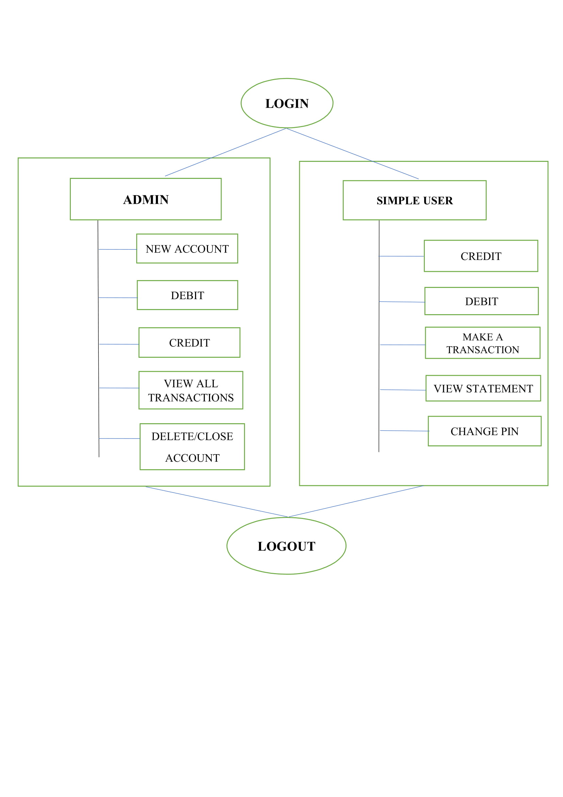

**3.3 Software Requirement Specification-**

* **Language- Java (core)**
* **Concept- Swing**
* **IDE- Netbeans**
* **Database- MySQL using Wamp server**

**3.4 Implementation Code –**

**Java code to implement login class:-**

package ASimulatorSystem;

import java.awt.*;

import java.awt.event.*;

import javax.swing.*;

import java.sql.*;

public class Login extends JFrame implements ActionListener{

JLabel l1,l2,l3;

JTextField tf1;

JPasswordField pf2;

JButton b1,b2,b3;

Login(){

setFont(new Font("System", Font.BOLD, 22));

Font f = getFont();

FontMetrics fm = getFontMetrics(f);

int x = fm.stringWidth("AUTOMATED TELLER MACHINE");

int y = fm.stringWidth(" ");

int z = getWidth() - x;

int w = z/y;

String pad ="";

//for (int i=0; i!=w; i++) pad +=" ";

pad = String.format("%"+w+"s", pad);

setTitle(pad+"AUTOMATED TELLER MACHINE");

l1 = new JLabel("WELCOME TO ATM");

l1.setFont(new Font("Osward", Font.BOLD, 38));

l2 = new JLabel("Card No:");

l2.setFont(new Font("Raleway", Font.BOLD, 28));

l3 = new JLabel("PIN:");

l3.setFont(new Font("Raleway", Font.BOLD, 28));

tf1 = new JTextField(15);

pf2 = new JPasswordField(15);

b1 = new JButton("SIGN IN");

b1.setBackground(Color.BLACK);

b1.setForeground(Color.WHITE);

b2 = new JButton("CLEAR");

b2.setBackground(Color.BLACK);

b2.setForeground(Color.WHITE);

b3 = new JButton("SIGN UP");

b3.setBackground(Color.BLACK);

b3.setForeground(Color.WHITE);

setLayout(null);

l1.setBounds(175,50,450,200);

add(l1);

l2.setBounds(125,150,375,200);

add(l2);

tf1.setBounds(300,235,230,30);

add(tf1);

l3.setBounds(125,225,375,200);

add(l3);

tf1.setFont(new Font("Arial", Font.BOLD, 14));

pf2.setFont(new Font("Arial", Font.BOLD, 14));

pf2.setBounds(300,310,230,30);

add(pf2);

b1.setFont(new Font("Arial", Font.BOLD, 14));

b1.setBounds(300,400,100,30);

add(b1);

b2.setFont(new Font("Arial", Font.BOLD, 14));

b2.setBounds(430,400,100,30);

add(b2);

b3.setFont(new Font("Arial", Font.BOLD, 14));

b3.setBounds(300,450,230,30);

add(b3);

b1.addActionListener(this);

b2.addActionListener(this);

b3.addActionListener(this);

getContentPane().setBackground(Color.WHITE);

setSize(750,750);

setLocation(350,50);

setVisible(true);

}

public void actionPerformed(ActionEvent ae){

try{

conn c1 = new conn();

String a = tf1.getText();

String b = pf2.getText();

String q = "select * from login where cardno = '"+a+"' and pin = '"+b+"'";

ResultSet rs = c1.s.executeQuery(q);

if(ae.getSource()==b1){

if(rs.next()){

new Transcations().setVisible(true);

setVisible(false);

}else{

JOptionPane.showMessageDialog(null, "Incorrect Card Number or Password");

}

}else if(ae.getSource()==b2){

tf1.setText("");

pf2.setText("");

}else if(ae.getSource()==b3){

new Signup().setVisible(true);

setVisible(false);

}

}catch(Exception e){

e.printStackTrace();

System.out.println("error: "+e);

}

}

public static void main(String[] args){

new Login().setVisible(true);

}

}

**3.5 Output Screenshots-**

* 1. **Login page**

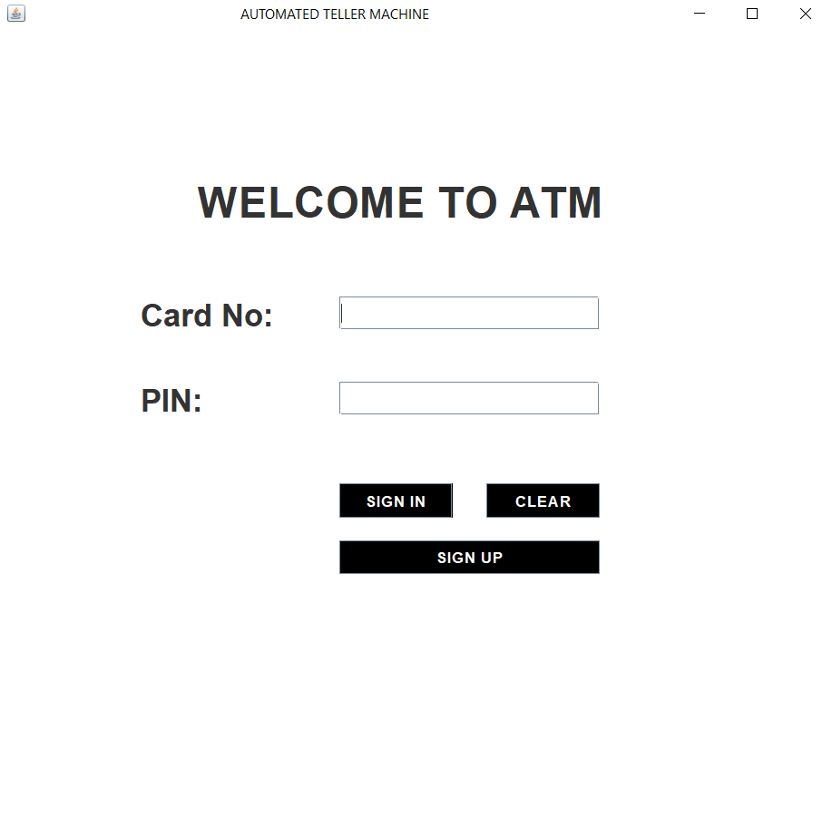

* 1. **Signup page 1**

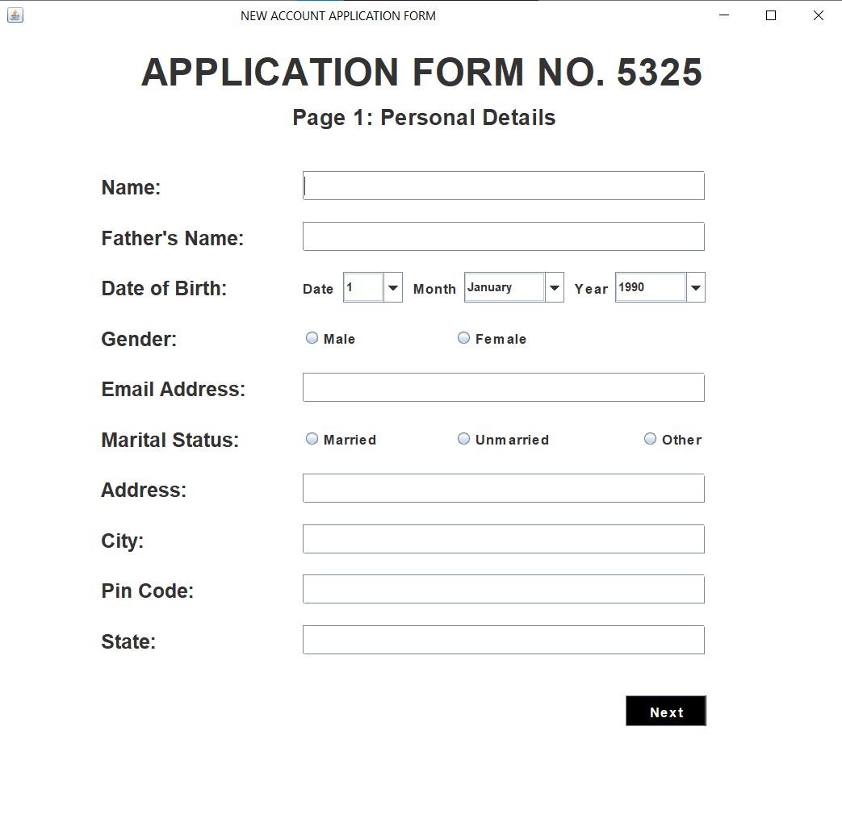

* 1. **Signup page 2-**

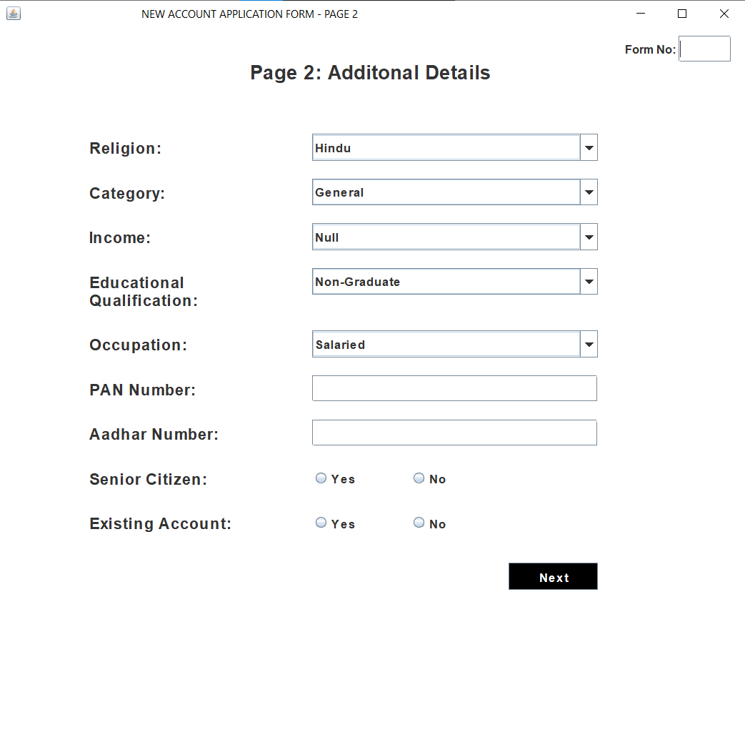

**4. Signup page 3-**

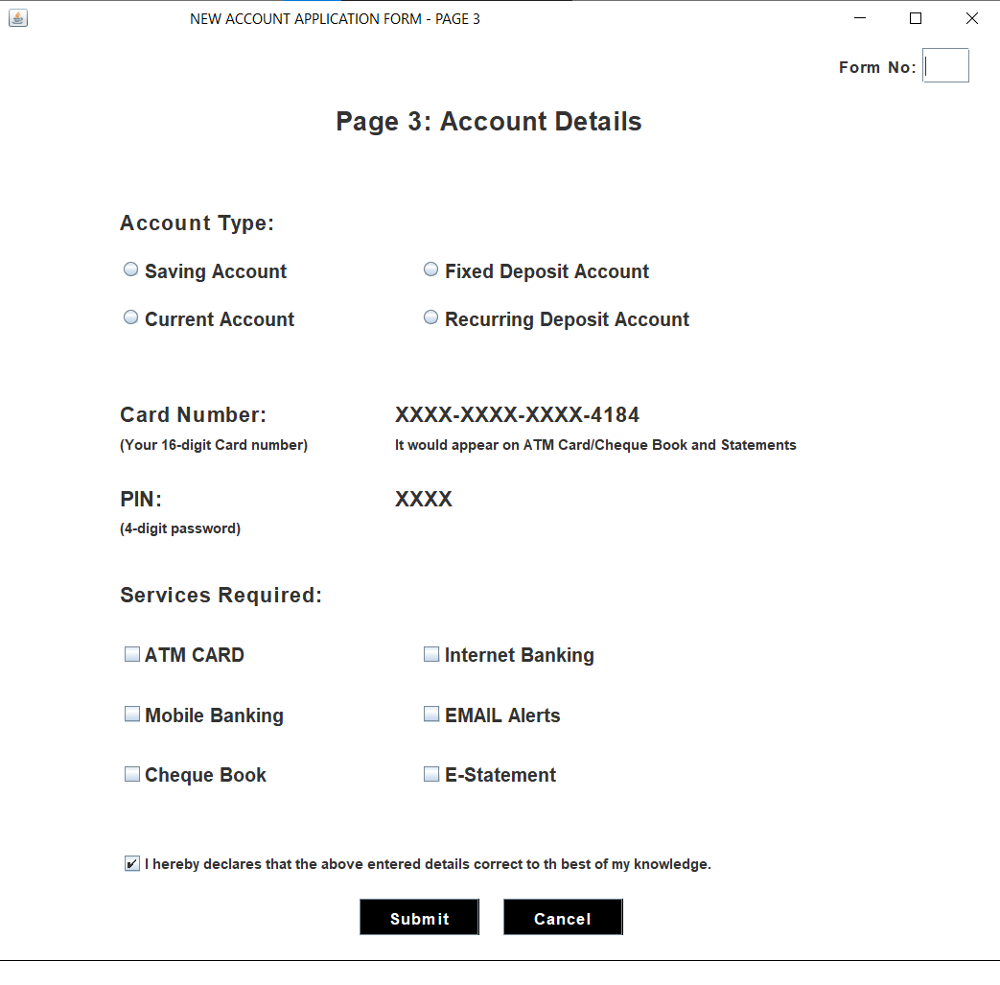

1. **Home page-**

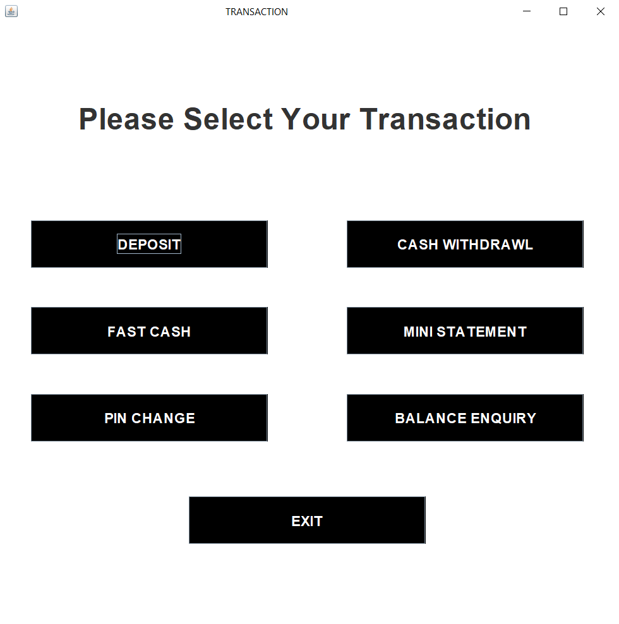

1. **Deposit money-**

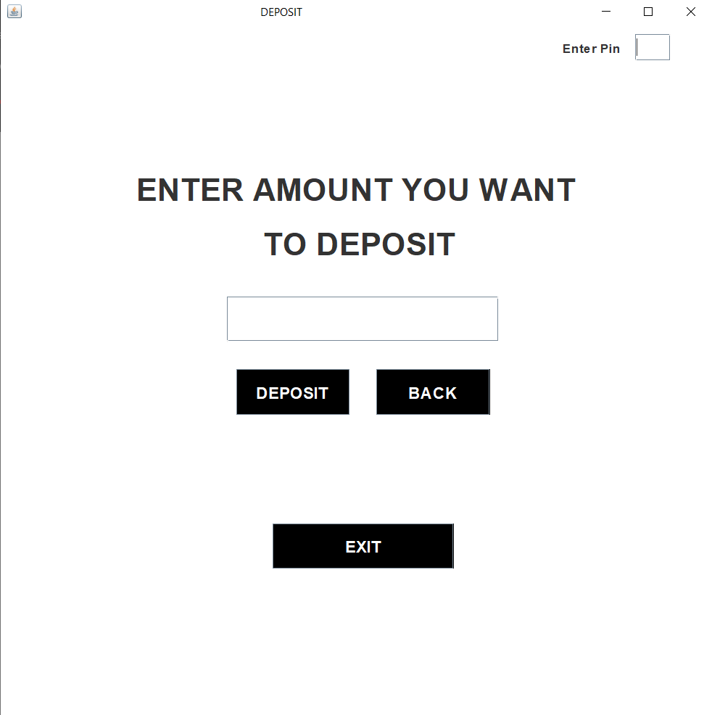

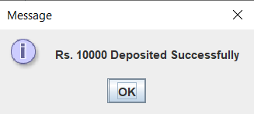

1. **Withdraw cash-**

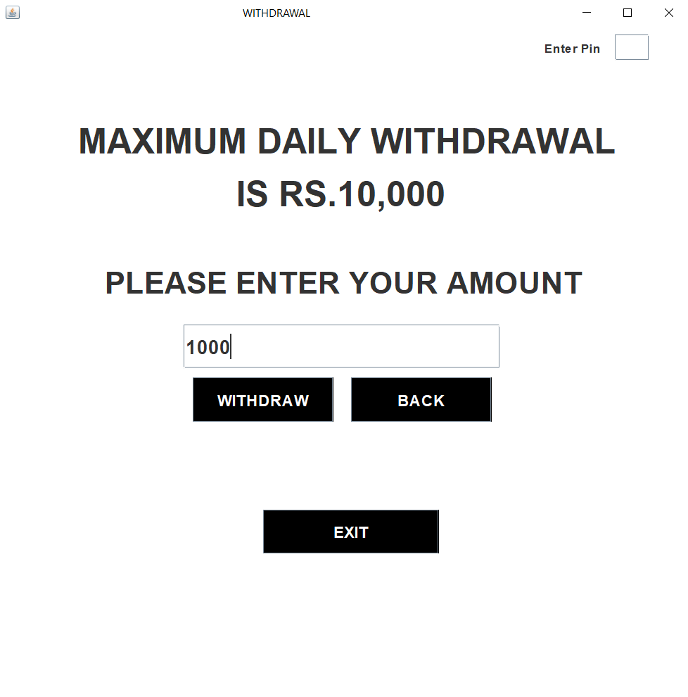

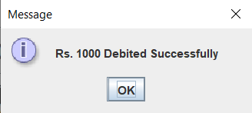

1. **Fast cash-**

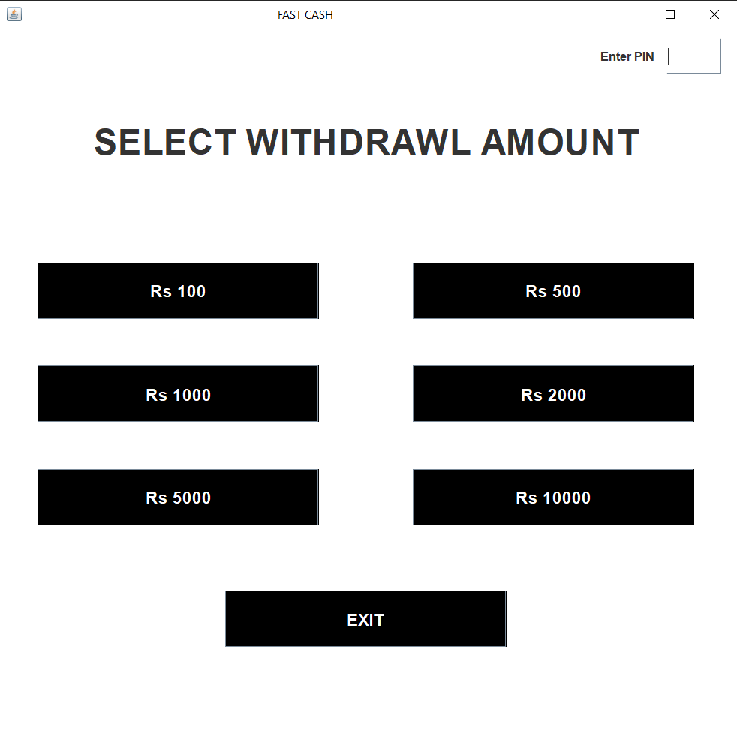

**4. Conclusion-**

* **This project is developed to nurture the needs of a user in a banking sector by embedding all the tasks of transactions taking place in a bank.**
* **The banking system are used manual working but when we used online banking system it is totally virtualization process which avoid manual process and converts it in automatic process**
* **Bank management system is saving the time with accuracy than bank manual system.**

**5. Future work-**

* **Adding SMS feature which will send a SMS to the customer when transaction will take place from their account**